***Queue Interface***

* *Data are stored and retrieved based on FIFO implementation*
* *Null element shouldn’t be inserted*
* *Queues provide additional insertion, extraction, and inspection operations. Each of these methods exists in two forms: one throws an exception if the operation fails, the other returns a special value (either null or false, depending on the operation). The latter form of the insert operation is designed specifically for use with capacity-restricted Queue implementations; in most implementations, insert operations cannot fail.*

|  |  |  |  |
| --- | --- | --- | --- |
|  | **Throws exception** | ***Returns special value*** | ***Comments*** |
| **Insert** | [add(e)](https://docs.oracle.com/javase/8/docs/api/java/util/Queue.html#add-E-) | [offer(e)](https://docs.oracle.com/javase/8/docs/api/java/util/Queue.html#offer-E-) | *Offer Returns false when Queue is full* |
| **Remove** | [remove()](https://docs.oracle.com/javase/8/docs/api/java/util/Queue.html#remove--) | [poll()](https://docs.oracle.com/javase/8/docs/api/java/util/Queue.html#poll--) | *Poll Returns null when Queue is empty* |
| **Examine** | [element()](https://docs.oracle.com/javase/8/docs/api/java/util/Queue.html#element--) | [peek()](https://docs.oracle.com/javase/8/docs/api/java/util/Queue.html#peek--) | *Peek Returns null when Queue is empty* |

***Deque Interface***

* *Double ended queue that supports the addition or removal of elements from either end of data structure*
* *It can be used as Queue or stack*
* *Array Deque and linked list implements this interface*

***Important Functions/Operations of Deque Interface***

|  |  |
| --- | --- |
| *Return type* | ***Methods*** |
| void | [addFirst](https://docs.oracle.com/javase/8/docs/api/java/util/LinkedList.html#addFirst-E-)([E](https://docs.oracle.com/javase/8/docs/api/java/util/LinkedList.html) e) |
| void | [addLast](https://docs.oracle.com/javase/8/docs/api/java/util/LinkedList.html#addLast-E-)([E](https://docs.oracle.com/javase/8/docs/api/java/util/LinkedList.html) e) |
| [Iterator](https://docs.oracle.com/javase/8/docs/api/java/util/Iterator.html)<[E](https://docs.oracle.com/javase/8/docs/api/java/util/LinkedList.html)> | [descendingIterator](https://docs.oracle.com/javase/8/docs/api/java/util/LinkedList.html#descendingIterator--)() |
| E | [element](https://docs.oracle.com/javase/8/docs/api/java/util/LinkedList.html#element--)() |
| E | [getFirst](https://docs.oracle.com/javase/8/docs/api/java/util/LinkedList.html#getFirst--)() |
| E | [getLast](https://docs.oracle.com/javase/8/docs/api/java/util/LinkedList.html#getLast--)() |
| boolean | [offer](https://docs.oracle.com/javase/8/docs/api/java/util/LinkedList.html#offer-E-)([E](https://docs.oracle.com/javase/8/docs/api/java/util/LinkedList.html) e) |
| boolean | [offerFirst](https://docs.oracle.com/javase/8/docs/api/java/util/LinkedList.html#offerFirst-E-)([E](https://docs.oracle.com/javase/8/docs/api/java/util/LinkedList.html) e)) |
| boolean | [offerLast](https://docs.oracle.com/javase/8/docs/api/java/util/LinkedList.html#offerLast-E-)([E](https://docs.oracle.com/javase/8/docs/api/java/util/LinkedList.html) e) |
| E | [peek](https://docs.oracle.com/javase/8/docs/api/java/util/LinkedList.html#peek--)() |
| E | [peekFirst](https://docs.oracle.com/javase/8/docs/api/java/util/LinkedList.html#peekFirst--)() |
| E | [peekLast](https://docs.oracle.com/javase/8/docs/api/java/util/LinkedList.html#peekLast--)() |
| E | [poll](https://docs.oracle.com/javase/8/docs/api/java/util/LinkedList.html#poll--)()) |
| E | [pollFirst](https://docs.oracle.com/javase/8/docs/api/java/util/LinkedList.html#pollFirst--)() |
| E | [pollLast](https://docs.oracle.com/javase/8/docs/api/java/util/LinkedList.html#pollLast--)() |
| E | [pop](https://docs.oracle.com/javase/8/docs/api/java/util/LinkedList.html#pop--)() |
| void | [push](https://docs.oracle.com/javase/8/docs/api/java/util/LinkedList.html#push-E-)([E](https://docs.oracle.com/javase/8/docs/api/java/util/LinkedList.html) e) |
| E | [removeFirst](https://docs.oracle.com/javase/8/docs/api/java/util/LinkedList.html#removeFirst--)() |
| boolean | [removeFirstOccurrence](https://docs.oracle.com/javase/8/docs/api/java/util/LinkedList.html#removeFirstOccurrence-java.lang.Object-)([Object](https://docs.oracle.com/javase/8/docs/api/java/lang/Object.html) o) |
| E | [removeLast](https://docs.oracle.com/javase/8/docs/api/java/util/LinkedList.html#removeLast--)() |
| boolean | [removeLastOccurrence](https://docs.oracle.com/javase/8/docs/api/java/util/LinkedList.html#removeLastOccurrence-java.lang.Object-)([Object](https://docs.oracle.com/javase/8/docs/api/java/lang/Object.html) o) |
| E | remove() |

*Refer:* [*https://docs.oracle.com/javase/8/docs/api/java/util/Queue.html*](https://docs.oracle.com/javase/8/docs/api/java/util/Queue.html)

***Important Functions/Operations of Collection interface***

|  |  |
| --- | --- |
| *Return Type* | **Methods** |
| boolean | [add](https://docs.oracle.com/javase/7/docs/api/java/util/Collection.html#add(E))([E](https://docs.oracle.com/javase/7/docs/api/java/util/Collection.html) e) |
| boolean | [addAll](https://docs.oracle.com/javase/7/docs/api/java/util/Collection.html#addAll(java.util.Collection))([Collection](https://docs.oracle.com/javase/7/docs/api/java/util/Collection.html)<? extends [E](https://docs.oracle.com/javase/7/docs/api/java/util/Collection.html)> c) |
| void | [clear](https://docs.oracle.com/javase/7/docs/api/java/util/Collection.html#clear())() |
| boolean | [contains](https://docs.oracle.com/javase/7/docs/api/java/util/Collection.html#contains(java.lang.Object))([Object](https://docs.oracle.com/javase/7/docs/api/java/lang/Object.html) o) |
| boolean | [containsAll](https://docs.oracle.com/javase/7/docs/api/java/util/Collection.html#containsAll(java.util.Collection))([Collection](https://docs.oracle.com/javase/7/docs/api/java/util/Collection.html)<?> c) |
| boolean | [equals](https://docs.oracle.com/javase/7/docs/api/java/util/Collection.html#equals(java.lang.Object))([Object](https://docs.oracle.com/javase/7/docs/api/java/lang/Object.html) o) |
| int | [isEmpty](https://docs.oracle.com/javase/7/docs/api/java/util/Collection.html#isEmpty())() |
| [Iterator](https://docs.oracle.com/javase/7/docs/api/java/util/Iterator.html)<[E](https://docs.oracle.com/javase/7/docs/api/java/util/Collection.html)> | [iterator](https://docs.oracle.com/javase/7/docs/api/java/util/Collection.html#iterator())() |
| boolean | [remove](https://docs.oracle.com/javase/7/docs/api/java/util/Collection.html#remove(java.lang.Object))([Object](https://docs.oracle.com/javase/7/docs/api/java/lang/Object.html) o) |
| boolean | [removeAll](https://docs.oracle.com/javase/7/docs/api/java/util/Collection.html#removeAll(java.util.Collection))([Collection](https://docs.oracle.com/javase/7/docs/api/java/util/Collection.html)<?> c) |
| boolean | [retainAll](https://docs.oracle.com/javase/7/docs/api/java/util/Collection.html#retainAll(java.util.Collection))([Collection](https://docs.oracle.com/javase/7/docs/api/java/util/Collection.html)<?> c) |
| int | [size](https://docs.oracle.com/javase/7/docs/api/java/util/Collection.html#size())() |
| [Object](https://docs.oracle.com/javase/7/docs/api/java/lang/Object.html)[] | [toArray](https://docs.oracle.com/javase/7/docs/api/java/util/Collection.html#toArray())() |
| <T> T[] | [toArray](https://docs.oracle.com/javase/7/docs/api/java/util/Collection.html#toArray(T[]))(T[] a) |

* Few methods like **equals(), hashCode(), toString ()** are overridden from object class

Refer <https://docs.oracle.com/javase/7/docs/api/java/util/Collection.html>

## *Additional info for Deque*

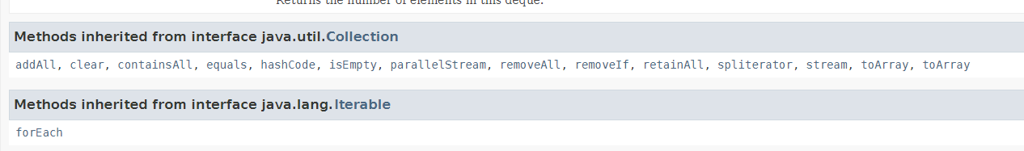

## *Additional info for Array Queue*

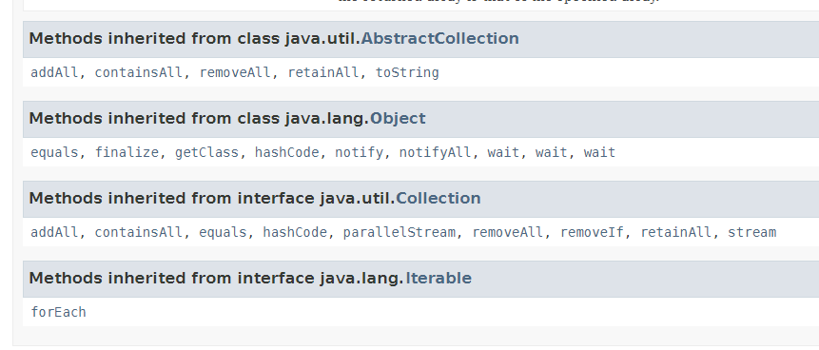

***Priority Queue***

* *Behaviour is similar to normal queue except that each element has some priority*
* *Element with highest priority will be removed first*
* *If 2 elements in same priority then they will be arranged FIFO order*
* *Priority for objects can be customized with Compartor (or) comparable interface*

***Important Functions/Operations of Priority Queue Interface***

|  |  |
| --- | --- |
| *Return type* | ***Methods*** |
| E | [element](https://docs.oracle.com/javase/8/docs/api/java/util/LinkedList.html#element--)() |
| boolean | [offer](https://docs.oracle.com/javase/8/docs/api/java/util/LinkedList.html#offer-E-)([E](https://docs.oracle.com/javase/8/docs/api/java/util/LinkedList.html) e) |
| E | [peek](https://docs.oracle.com/javase/8/docs/api/java/util/LinkedList.html#peek--)() |
| E | [poll](https://docs.oracle.com/javase/8/docs/api/java/util/LinkedList.html#poll--)()) |

*Refer:* [*https://docs.oracle.com/javase/7/docs/api/java/util/PriorityQueue.html*](https://docs.oracle.com/javase/7/docs/api/java/util/PriorityQueue.html)

***Important Functions/Operations of Collection interface***

|  |  |
| --- | --- |
| *Return Type* | **Methods** |
| boolean | [add](https://docs.oracle.com/javase/7/docs/api/java/util/Collection.html#add(E))([E](https://docs.oracle.com/javase/7/docs/api/java/util/Collection.html) e) |
| boolean | [addAll](https://docs.oracle.com/javase/7/docs/api/java/util/Collection.html#addAll(java.util.Collection))([Collection](https://docs.oracle.com/javase/7/docs/api/java/util/Collection.html)<? extends [E](https://docs.oracle.com/javase/7/docs/api/java/util/Collection.html)> c) |
| void | [clear](https://docs.oracle.com/javase/7/docs/api/java/util/Collection.html#clear())() |
| boolean | [contains](https://docs.oracle.com/javase/7/docs/api/java/util/Collection.html#contains(java.lang.Object))([Object](https://docs.oracle.com/javase/7/docs/api/java/lang/Object.html) o) |
| boolean | [containsAll](https://docs.oracle.com/javase/7/docs/api/java/util/Collection.html#containsAll(java.util.Collection))([Collection](https://docs.oracle.com/javase/7/docs/api/java/util/Collection.html)<?> c) |
| boolean | [equals](https://docs.oracle.com/javase/7/docs/api/java/util/Collection.html#equals(java.lang.Object))([Object](https://docs.oracle.com/javase/7/docs/api/java/lang/Object.html) o) |
| int | [isEmpty](https://docs.oracle.com/javase/7/docs/api/java/util/Collection.html#isEmpty())() |
| [Iterator](https://docs.oracle.com/javase/7/docs/api/java/util/Iterator.html)<[E](https://docs.oracle.com/javase/7/docs/api/java/util/Collection.html)> | [iterator](https://docs.oracle.com/javase/7/docs/api/java/util/Collection.html#iterator())() |
| boolean | [remove](https://docs.oracle.com/javase/7/docs/api/java/util/Collection.html#remove(java.lang.Object))([Object](https://docs.oracle.com/javase/7/docs/api/java/lang/Object.html) o) |
| boolean | [removeAll](https://docs.oracle.com/javase/7/docs/api/java/util/Collection.html#removeAll(java.util.Collection))([Collection](https://docs.oracle.com/javase/7/docs/api/java/util/Collection.html)<?> c) |
| boolean | [retainAll](https://docs.oracle.com/javase/7/docs/api/java/util/Collection.html#retainAll(java.util.Collection))([Collection](https://docs.oracle.com/javase/7/docs/api/java/util/Collection.html)<?> c) |
| int | [size](https://docs.oracle.com/javase/7/docs/api/java/util/Collection.html#size())() |
| [Object](https://docs.oracle.com/javase/7/docs/api/java/lang/Object.html)[] | [toArray](https://docs.oracle.com/javase/7/docs/api/java/util/Collection.html#toArray())() |
| <T> T[] | [toArray](https://docs.oracle.com/javase/7/docs/api/java/util/Collection.html#toArray(T[]))(T[] a) |

* Few methods like **equals(), hashCode(), toString ()** are overridden from object class

Refer <https://docs.oracle.com/javase/7/docs/api/java/util/Collection.html>

## *Additional info for Priority queue*

